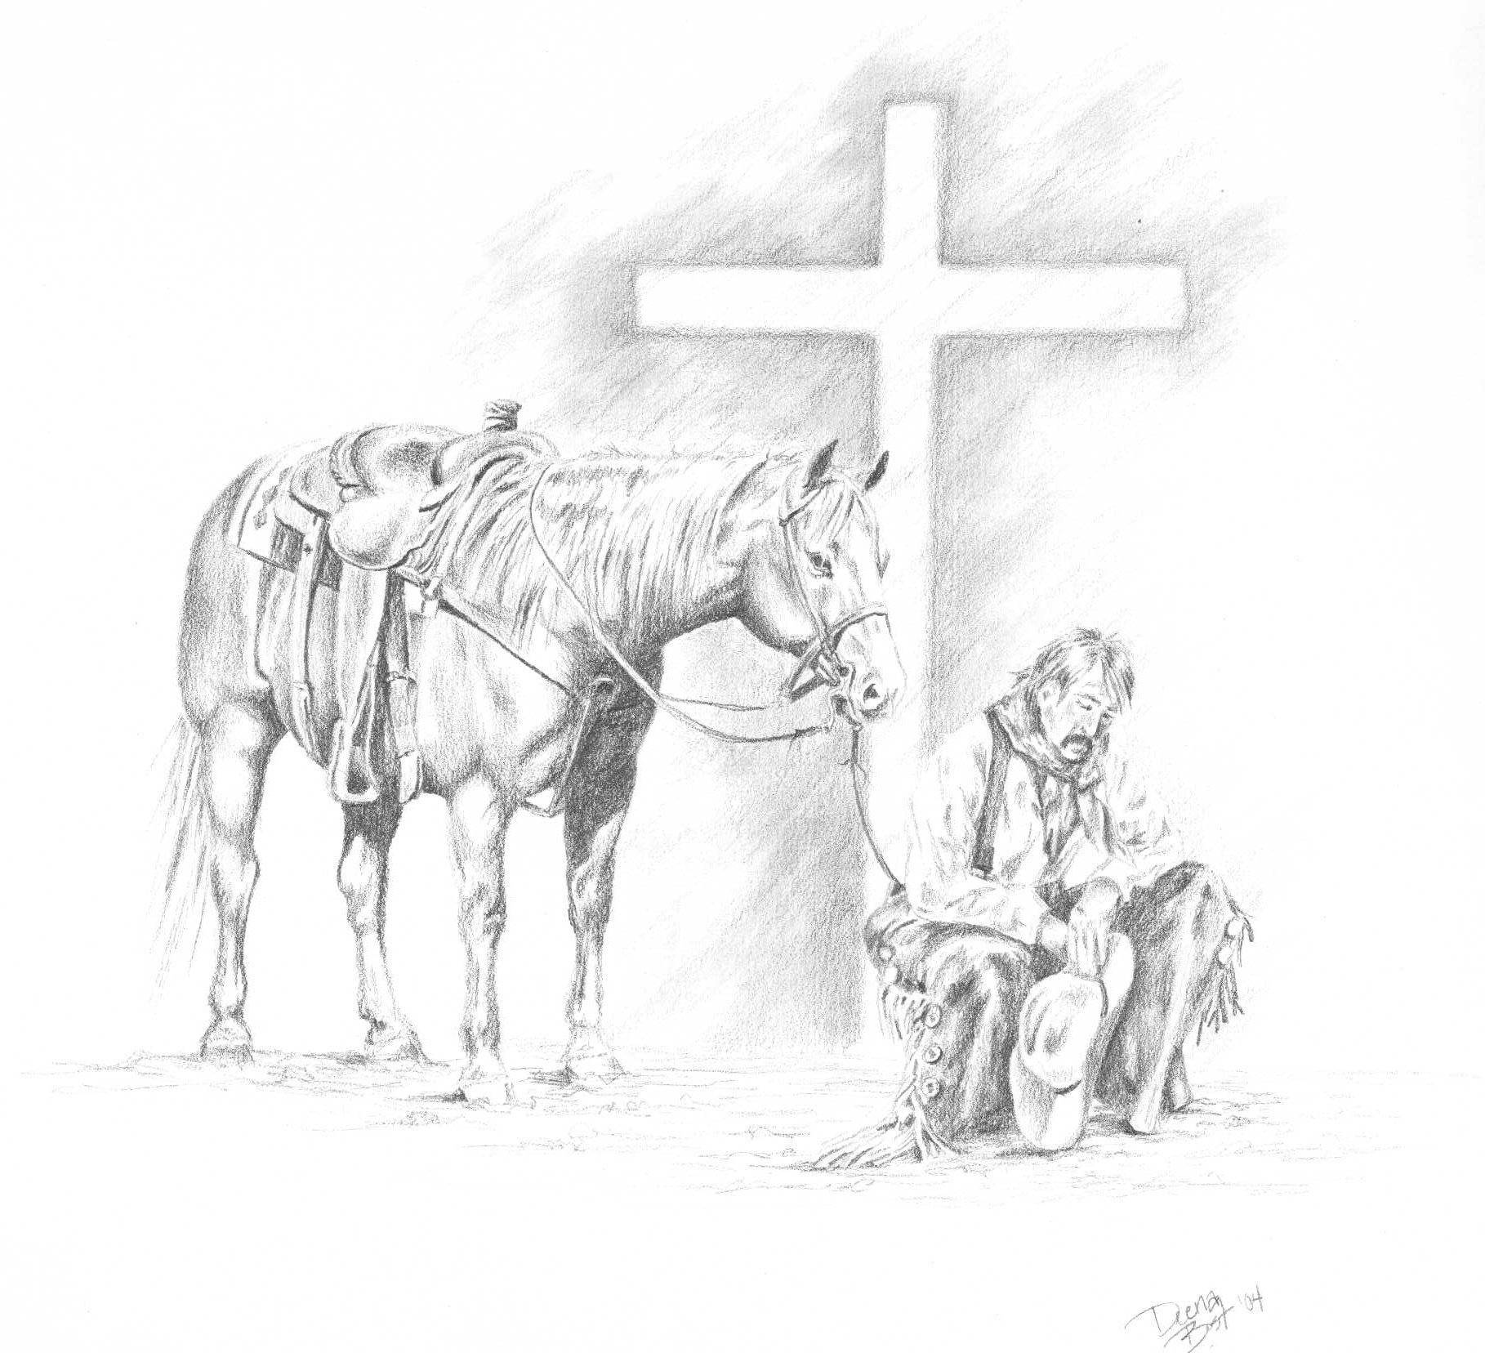
Happy Trails
Cowboy Church

History

Happy Trails Cowboy Church held its first service on Monday, October 25, 2004 with 80 in attendance and 6 professions of faith made during the invitation at the close of the service. The church was an intentional new church plant of the Catawba Valley Baptist Association as part of the Baptist State Convention of North Carolina’s “Light Up North Carolina” church planting vision. The association agreed to start four new churches, with the first one being a church for the post-modern culture, followed by a church for the Vietnamese population. Recognizing the great need for a church who understood the needs of the “cowboy” subculture, the association partnered with Covenant Baptist Church of Conover, NC to begin a cowboy church. There are many “cowboys and cowgirls” who cannot or do not attend traditional church meetings on Sunday mornings because they are traveling on weekends as they perform on the rodeo circuit or are traveling to trail ride with their horses, thus the decision to hold services on a weeknight. But you don’t have to be a cowboy to attend cowboy church. The common thread that draws most folks to cowboy church is “it’s simple” basics taught in the Bible without a lot of man added fluff.
Pastor Don Martin, of Covenant Baptist Church, and also Chair of the association’s Mission Development Team and Vice-Moderator, was asked to investigate the effectiveness of the cowboy church movement beginning in North Carolina, led by Pastor Jeff Smith of Midland, NC. God impressed upon Pastor Martin the need for the cowboy church and placed a call upon him to start this new church. This was not an easy decision, as Pastor Martin already had a full-time secular job in addition to his responsibilities as pastor of Covenant Baptist Church and being very active in the association.
An arena facility in Alexander County of NC was secured and the decision was made by the Catawba Valley Association to proceed. Pastor Martin agreed to serve as the founding pastor and announced to his church that he would also be taking on the role of pastor of the new Happy Trails Cowboy Church. Unknown to him, the Deacons, Missions Committee, and Finance Committee of Covenant Baptist Church called urgent meetings to discuss the announcement, and decided unanimously in less than one week that they wanted to support this new church as the sponsoring church. The church approved the plan the next week and graciously took $10,000 from their building fund to donate to the cowboy church to purchase bleachers for seating. Also, the Catawba Valley Association gave nearly $3,000 to purchase a sound system and advertising. The ride for Jesus had begun in record time, just 8 weeks from conception until the first service. This indeed was a “God thing” that no man could possibly do. Happy Trails Cowboy Church became the third cowboy church in what is now "Cowboy Church Network of North America", a movement based in North Carolina that has spread all across the US and Canada, with the cowboy church movement being the fastest growing ministry in the country and countless souls being led to Christ.
THE MISSION
The church met as a mission from October 2004 until it constituted in March 2005. In obedience to the Word of God that there is but one church, Happy Trails Cowboy Church has members as do all Baptist churches, but also has “partners” who are active members of another local church but want to be part of the ministry of Happy Trails Cowboy Church. Also, strongly believing in tithing, the church agreed to set an example for the members by itself promising to always give at least ten percent of the offerings to missions and benevolence. Usually, that percentage averages between thirty and fifty percent each year. The church chose to affiliate with the Alexander Baptist Association, the Baptist State Convention of NC, the Southern Baptist Convention, and the Cowboy Church Network of North America based in Midland, NC.
The purpose of the cowboy church is to reach folks who have an affinity with the cowboy culture, enjoy horses, farming, country living, or just want to worship and experience God in a relaxed atmosphere. We want to break down barriers, both real and perceived, and help people connect with their Creator through His son Jesus Christ. Once the barriers have been removed and a person accepts Jesus Christ as their personal Lord and Savior, the Holy Spirit is free to do His part to make disciples of us believers, teaching us to observe His commandments and accept His promise of abundant and eternal life.
Cowboy church is unique in several ways such as meeting on Mondays at 7pm instead of Sundays to reach the rodeo and trail riding cowboys and cowgirls, meeting in a horse/rodeo arena rather than a “church building” (after all, Jesus chose to be born in a stable rather than a palace), dirt floors rather than carpet, bleachers rather than pews, little heat in the winter and no air conditioning in the summer, a “come as you are” dress code (boots, jeans, western attire are OK), Bluegrass and/or Country/Southern Gospel bands each service, no pulpit - pastor preaches as he walks around on the dirt floor, and simple, easy to understand messages straight from the Bible.
Happy Trails Cowboy Church is serious about being a hospital for sinners rather than a social club for saints, and is active in sharing Christ with the community. Over the years we have ministered through events such as the annual Southern Rodeo Association/International Professional Rodeo Association, Gospel Singings, Horse Fun Shows and various other community outreach activities.
Benevolence and Missions is a vital and important part of how we share Christ with our community and the world. Among the missions that we support or have supported are the Cooperative Program of the SBC, the Cowboy Church Network of North America, Alexander Baptist Association, Taylorsville Rotary Club (Backpack Food program), Caring Hearts Pregnancy Care Center (Taylorsville), Christian Crisis Center (Alexander County), Alexander County Baptist Christmas Toy Store, Habitat for Humanity, Alexander Prison Ministry, Samaritan’s Purse, Shelter Rock Ministries (Appalachian & Native American ministries), several State Farm Bureaus to aid in disasters, and local and national benevolence.
THE PRESENT
In December 2010, Happy Trails Cowboy Church relocated to it's present location at 35 Rogers Farm Lane in Hiddenite NC. We are grateful to the Meadowbrook Saddle Club to be leasing their facilities for our ministry.
In May 2020, Happy Trails Cowboy Church changed our meeting night for worship to Thursday nights at 7pm and Bible Study to the 2nd and 4th Tuesdays at 7pm.
Outreach ministries is a vital part of our church fulfilling its mission to reach the cowboy culture. Please visit our Outreach Ministries page to see the exciting mission opportunities we are involved in - such as our Wild West Day annual community event - Cowboy Mounted Shooting ministry - Rodeos and more! We invite you to come be a part of all God's blessings at Happy Trails!

